Title: Vehicle Detection and Monitoring using Magnetic field Sensors.

Aim: To develop a traffic monitoring and classification system using low power, low cost magnetic sensors and induction loops that can be used to record traffic parameters such as vehicle speed, count and class of vehicle. These parameters are used to compile a database that can be used as a reference by city planners.

Motivation:

Alleviation of traffic congestion by improving the efficiency of the current transportation system.

Solution: Real-time traffic surveillance

Requirement: cost-efficient and accurate estimation of traffic parameters.

The most popular methods of acquiring traffic parameters that are currently used in India, i.e. video image processing and infrared sensors, suffer from several drawbacks such as dependence on clear environmental conditions and suitable ambient light requirements.

Hence the need for a sensor that is independent of the environmental conditions to a large extent. Magnetic field sensors satisfy all the above requirements.

General Block diagram:

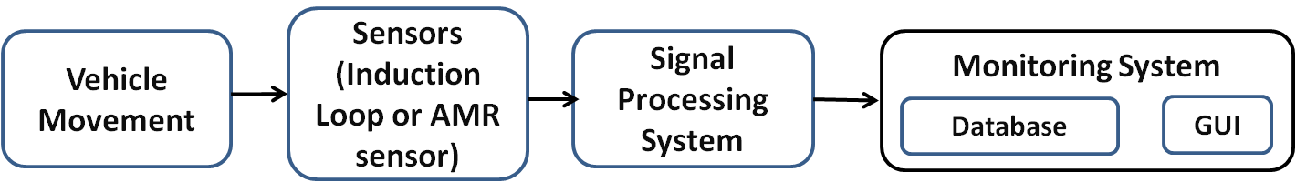

Block diagram of Induction Loop vehicle detection system

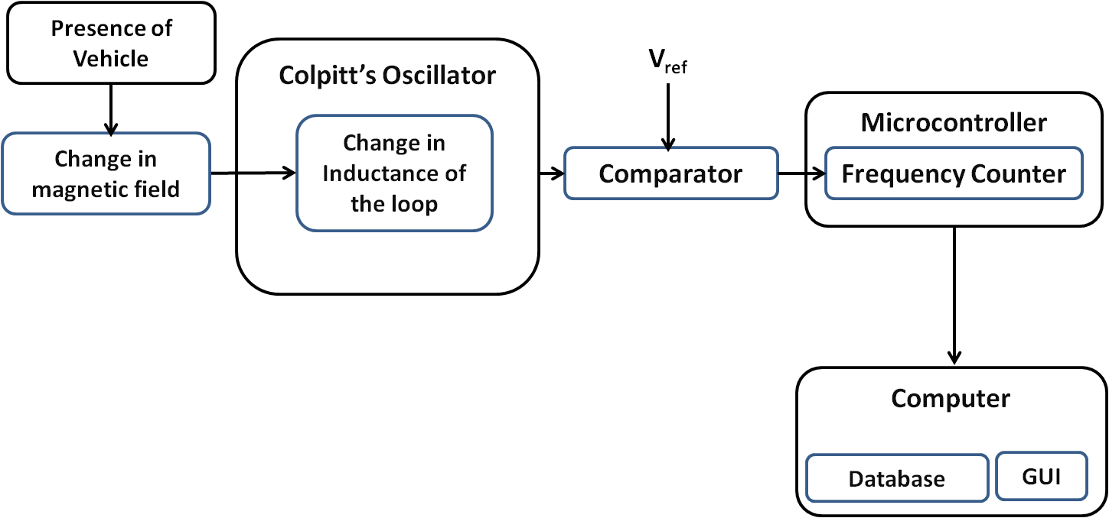

Functioning of Induction Loop vehicle detection system:

* The inductive-loop is a part of the tank circuit of a Colpitt’s oscillator in which the loop wire and lead-in cable are the inductive elements.
* The comparator acts as an A/D convertor and converts the analog output signal of the oscillator into a square wave.
* This is fed to a microcontroller which continuously measures the frequency of the square wave input.
* When a vehicle passes over the loop or is stopped within the loop, the vehicle induces eddy currents in the wire loops, which decrease their inductance. The decreased inductance results in an increase in the frequency of the oscillator output.
* This increase in frequency is used by the microcontroller to detect the presence of vehicles
* The amount of eddy currents induced in the loop and thus the change in frequency depends on the mass of the ferromagnetic material in the proximity of the loop.
* Since two wheelers and four wheelers have different amounts of ferromagnetic material in them, the corresponding frequency change as they pass over the loop is also different. This difference is used by the microcontroller to classify the vehicles.
* The traffic parameters i.e. the count and classification of vehicles is then sent by the microcontroller to a computer where they are displayed in the GUI and stored in a database.

Flow chart for Induction Loop vehicle detection system:

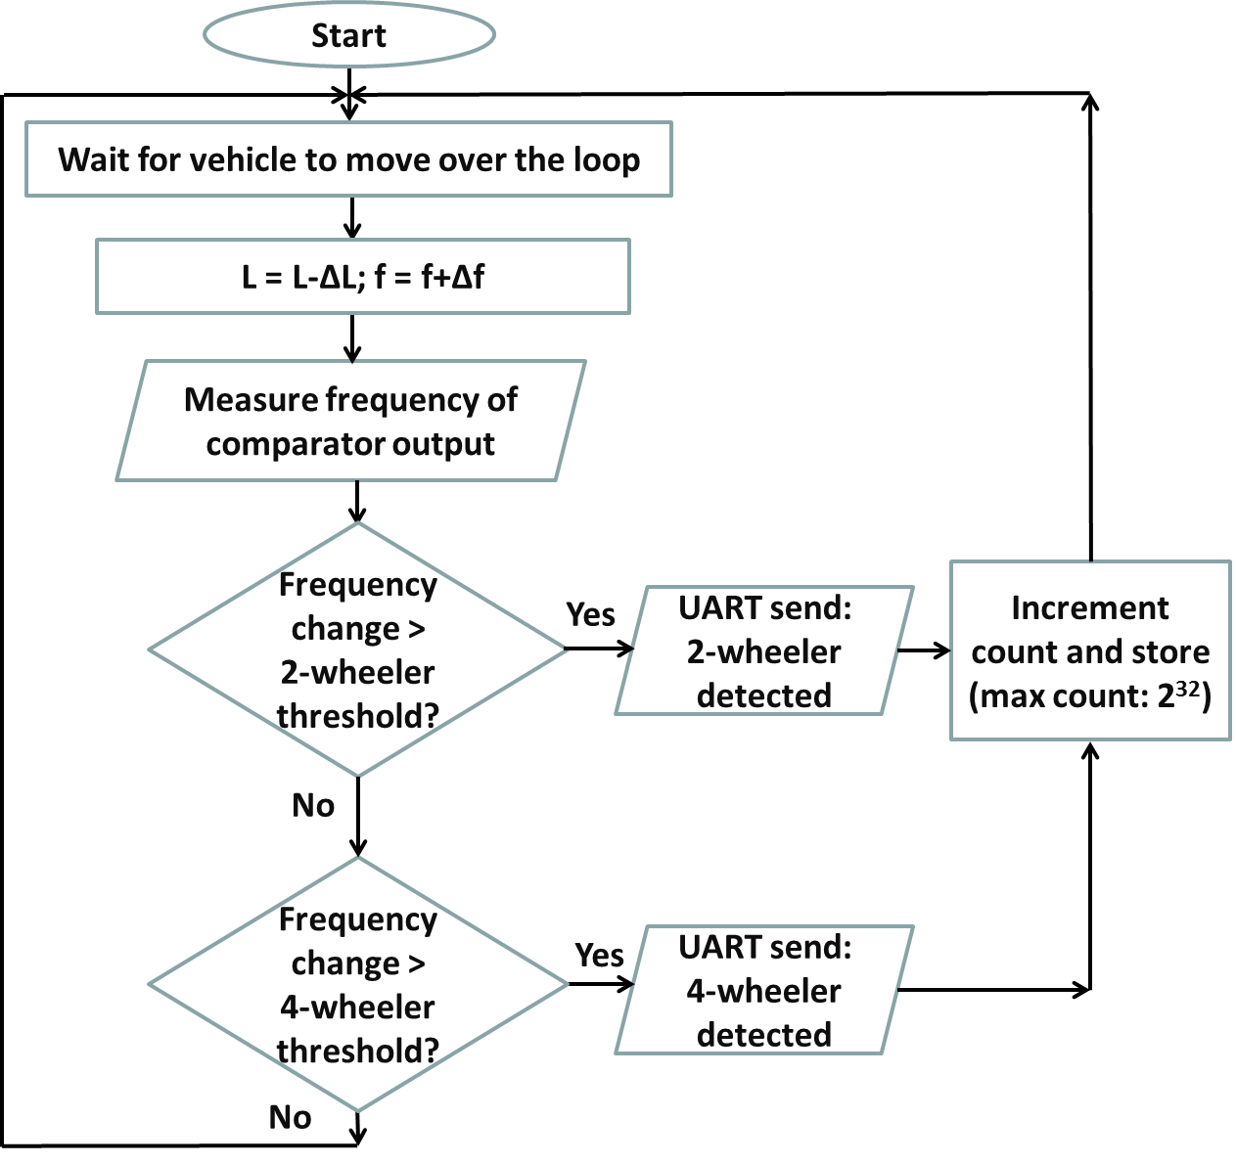

Block diagram of AMR sensor vehicle detection system:

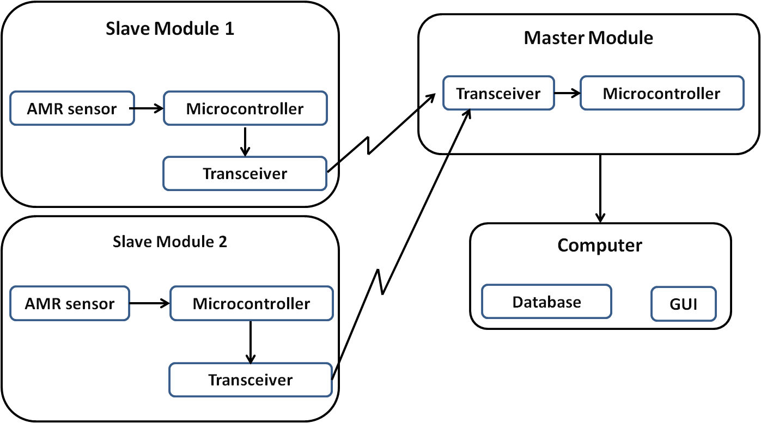

Functioning of AMR sensor vehicle detection system:

* The system consists of two sensor modules which act as slaves and a core module which acts as a master. The slave modules communicate wirelessly with the master module via the ZigBee protocol.
* The sensors on the slave modules detect the change in the ambient magnetic field. When a ferromagnetic material passes over the sensor it disturbs the magnetic field around it. This change in magnetic field causes a change in the resistance of the amr element, causing a change in the sensor’s output voltage.
* An EWMA (Exponentially weighted moving average) filter is used to eliminate the noise in the sensor output.
* An algorithm running on the slave module that monitors the slope of the waveform when the sensor outputs cross a threshold is used to detect that a vehicle has passed over it.
* When a vehicle is detected, a time stamp indicating the time at which the vehicle crossed over the sensor is sent to the master module.
* The slave modules are buried along the length of the road with a distance of two meters between them.
* Thus the time stamps sent by the two slave modules differ by a small value Δt as the vehicle passes over the two sensors one after the other.
* This difference is used to find the speed of the vehicle using the formula

S = D/Δt

Where S is the speed,

D is the distance between the two sensors

Δt is the time difference.

Flow chart for slave module:

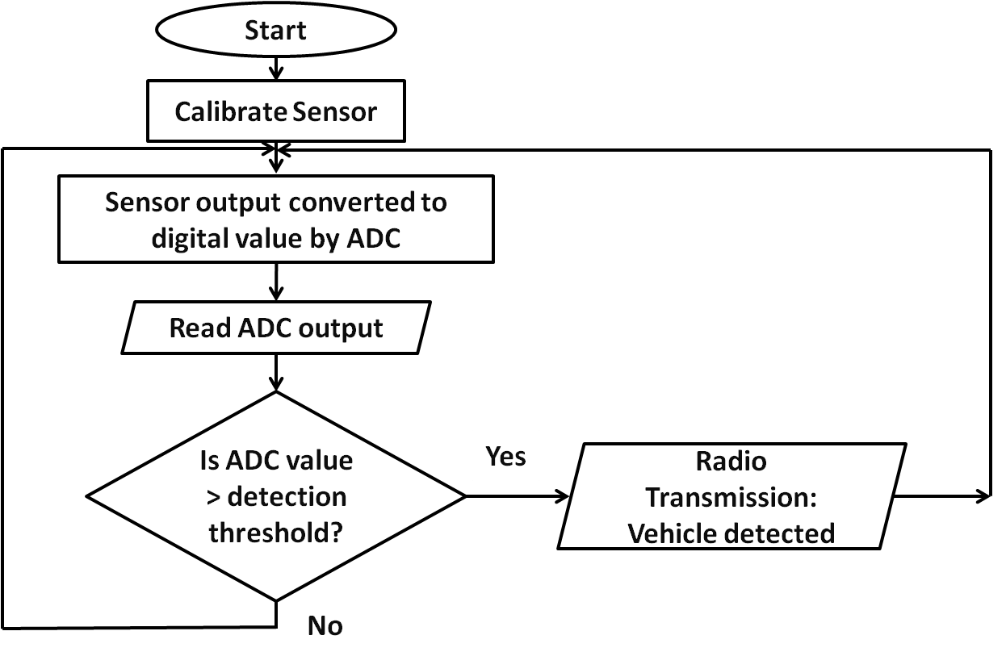

Flow chart for Master module:

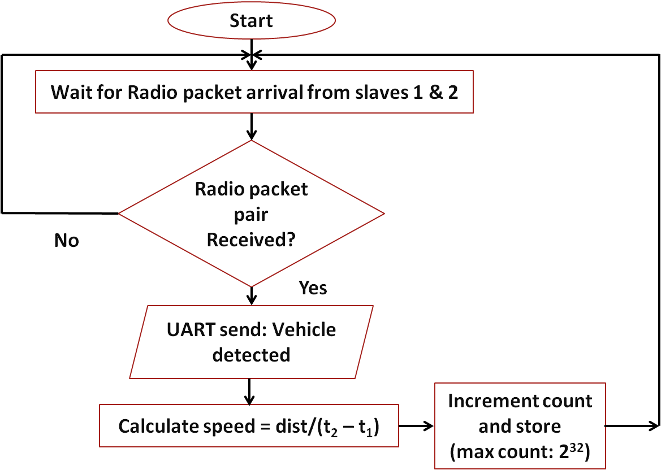

Results for Induction loop vehicle detection system:

Frequency drift is found to decrease with speed in case of both two wheelers and four wheelers.

No. of trials = 50

No. of times a vehicle went undetected or detected more than once = 4

No. of times a two wheeler was detected as a four wheeler or vice versa = 5

**Accuracy of count = 92%**

**Accuracy of classification= 90%**

Results for AMR vehicle detection system:

No. of trials = 25

No. of times a vehicle went undetected or detected more than once = 1

**Accuracy of count= 96%**

**Average error in detected speed = 9.26%**

Conclusion:

Magnetic sensors are found to be more reliable than Induction loop due to the following reasons:

* Significant and reliable change in magnetic field occurs only when the vehicle is completely inside the loop.
* Magnetic sensors are more economical compared to inductive loops as they are easy to reinstall and maintenance costs are low.
* Magnetic sensors have proven to be more immune to noise and stable compared to frequency drifts occurring in the induction loop system due to environmental changes.